BLACKDOWN BEAUTY 2017 LEGS A-C

LEG A - Priors Park Farm to Merry Harriers ~ 3.5 mi
1. From the farm through gate and follow to footpath down between fields to next gate.
2 Then right on path down to wood. Path through wood narrow, wet, slippery and stony. Ignore any tracks to left or right.
3. Through gate at end of wood and on to gate at Quarry house. Carry on past the buildings and down Quarry Lane to the T-junction.
4. Turn left then immediately right thru swing gate, on other side of the road and onto the path in meadow. Don’t bear left but go across the meadow keeping to the right hand hedge to the road.
5. CARE! Cross over and turn left up the road for about 30m, to footpath (lane). Follow footpath up lane then on narrow path between hedges to stile before a field.
6. Cross the field to footpath junction. Go straight ahead over the stile into 2nd field. Follow left-hand hedge 30m to next stile.
7. Over this and turn right and follow hedge line to field track. Cross over, bearing left to footbridge. Other side of bridge turn left and follow path to private road. Turn right and follow to junction with public lane. Turn left, continue to where road bends to the right.
8A Go ahead through gate into field. Follow tractor tracks just inside the gate to the right. This takes you around the bottom of the field and up the field with the hedge on your right. There is a lone group of three trees in this hedge (about ½ way up) and amongst them there is a hidden overgrown stile. Go over stile and turn left on road.
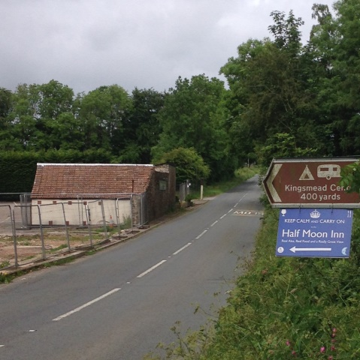
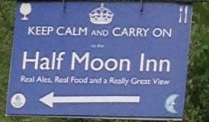
9. Follow road up the hill to angled road on right. Follow this past Leigh Hill Cottage to junction.
10. Across junction & through left-hand gate into Quants Wood (sign). Follow FP up through wood (ignoring Rt turn)
to road.
11. Rt onto road up 400m to the old site of the Merry Harriers pub (burnt down). See photos.

LEG B - Merry Harriers site to Pear Tree Cottage ~ 3.2 mi
1. Take minor road at side of site for 300m. Turn left onto FP then immediate right through woods. Follow path past campsite down to lane once through campsite.
2. Turn left then turn immediately right onto hidden path (FP post obscured by undergrowth. Go down through wood and over nice new wooden footbridges (no more bogs!) bearing right to stile.
3a. Follow FP down to gate (has to be climbed) then up to large tree (go the right of the tree) & down to 2nd gate. Open & close with care. Go straight along top of field by hedge to footbridge. Across footbridge then follow FP (left) through reeds up to gate. 3b. Keep left of fence to new wooden gate . Avoid public footpath thru five bar gate ahead as this goes through dog and horse area. Go over bank and then through another new gate. Go straight ahead and follow fence round horse exercise yard –Go through gate in fence opposite then ahead across field to gate and narrow track. Turn right onto Laurel bush covered path and follow path up to lane.
4. Turn left up lane to road (LEG 3 turns right here).Turn left and follow road round bend to farm. (LEG 4B joins route from FP on rt)
5. Through gate on left opp. farm and down field to next gate. Then follow boggy path down to small lake and on out of the trees.
6 Cross new wooden bridge, follow track up hill , 100 mtrs. to new sign post on right, DO NOT continue to the small building. Turn immediately left as signed path. Go through tree gap to second new sign post up to a field with fence and hedge on your right. Follow hedge line straight ahead to wooden gate. Carry on ahead alongside hedge through fields to road.
7. Turn right on road and follow for half mile down hill and over bridge and stream.
8. Just round the bend from stream turn left (just after gate) up bank to stile and FP (quite hidden).
9. Go through field on up to top and road. Follow road left past pink house and up the hill to Court Farm.
10. Opposite the farm go over the stile by the left gate and follow the grassy track to hedge then follow hedge line
left up to road.
11. Over road onto FP. Follow hedge to stile. Go straight over field towards 2 gates. Go through right-hand gate and follow track down to Grabham Fm and road at Stapley. Turn left and follow to Pear Tree Cottage (CREAM TEA!)

LEG C - Pear Tree Cottage to Priors Park Fm ~ 3.6 mi
1. From Pear Tree Cottage go left 20 yds to start of footpath on opp. side of road. Follow track up to gates. Path goes
down narrow grassy lane on rt.,
2. Follow to gate then on to rusty gate. Over this into field. Follow edge of field to the rt. to stile on far side.
3. Into next field. Next stile is near corner of field diagonally left. Go left negotiating any temporary fences.
4. Into another crop field. FP goes diagonally right through crop towards open shed, BUT can go right and follow hedge round. After the shed follow track alongside hedge to road.
5. Turn rt. along road then rt. at junction. Go just past Churchstanton church and take FP on left down 2nd driveway.
6. Follow FP down lower side of field to junction with broad track under trees (not to Red Lane as on FP post). Go straight across and follow path to middle track.
7. Go diagonally rt. to FP sign and on down to Tricky Warren.
8. Follow footpath round to road. Go left for 200 yds then left along the main road (CARE V.BUSY). Go past private road entrance on left then cross road to stile and FP.
9. Follow track to gate. Go through to field. FP goes diagonally left towards gate but follow rt. hand edge of field round to gate. Then on down to next gate.
110. Go left then right down grassy lane. Follow this down to road.
11. Turn left along road for 0.6 miles to X-road. Straight on to Holman Clavel.
12. Just past the pub cross into track. Go over gate by Forestry sign then on a short way, turn left over bank (signed) onto temporary route into field. Follow hedge line down to Priors Park Farm. YOU MADE IT!
NB. IF YOU GET LOST AT THIS POINT TAKE CARE GOING THROUGH A FIELD WITH COWS/BULL. THESE ANIMALS MAY NOT BE VERY FRIENDLY.

