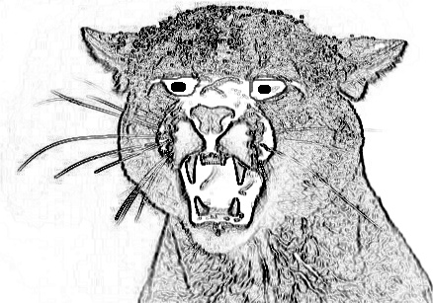
Honiton Running Club present
THE BLACKDOWN BEAST
Saturday 24th January 2015, 10 am
Start/Finish: Highfield Sport and Social Club, Culm Way, Dunkeswell EX14 4JP

A 16 MILE SOCIAL RUN with lots of beautiful countryside, splendid company and MUD
10 mile version available with transport back to the start – you must select this to be certain of a lift back
The run will be in four legs as follows:
Leg 1 ~ 7.25 miles to Smeatharpe Village Hall (mulled cider and hot pasty FREE)
Leg 2 ~ Smeatharpe 2.8 miles to Sidmouth Arms, Upottery (Finish of 10 mile option)
Leg 3 ~ Upottery 3.3 miles to Luppitt Inn
Leg 4 ~ Luppitt 2.7 miles to Highfield Club, Dunkeswell (Hot food on offer – need to pay)

Please note this is a social event and not a race. Runners participate at their own risk.
------------------------------------------------------------------------------------------------------------------------------------------

The Blackdown Beast - Saturday 24th January 2015, 10 am. More details at www.honitonrc.com

Entry Fee £10 to include map, instructions, hot pasty and drink (mulled cider or tea) at first stop (Smeatharpe)
Cheques to be made payable to: Honiton Running Club. All profits to McMillan Cancer Charity

I choose to enter the event at my own risk

Name:
Male/Female:
Address:
Postcode:
Tel:
Email:
Club (if any):
Distance (tick) | Full Course (16 miles) |  | 10 miles & transport back to start
Pasty type | Veggie |  | Meat

Closing date for receipt of postal entries is Monday 19th January
BUT this event sold out by mid-December last year
Return form to: Roger Saunders, Placidus, Barrow Road, Payhembury, Honiton, Devon. EX14 3HX
Please check www.honitonrc.com & Blackdown Beast page for up-to-date details

